|  |
| --- |
| NORTHWEST DEVICES CORPORATION |
| NWD-103 Series Barrier |
| USER MANUAL |
|  |
|  |

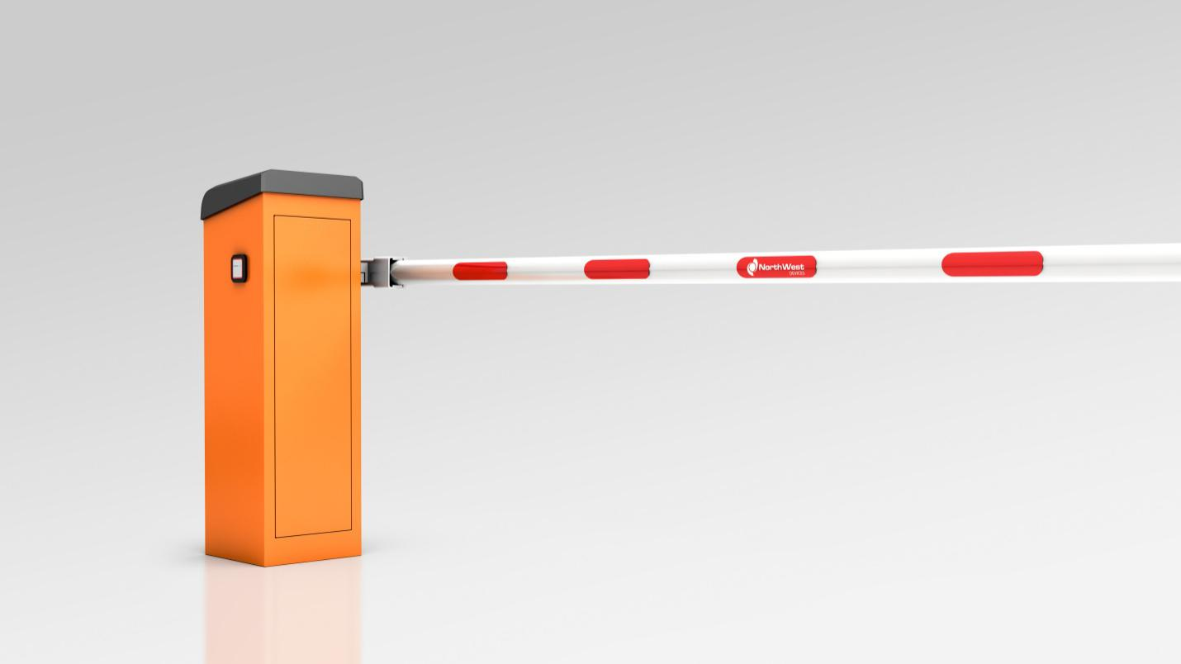

|  |
| --- |
| Version 01 Rev 01 |

**Table of contents**

1. GENERAL 5

1.1. Scope of This Manual 5

1.2. Warning Notes 6

1.3. Inspect the Shipment 7

1.4. Warranty 7

1.5. Caution 8

1.6. Service 8

1.7. Limitation of Liability 8

2. SAFETY 9

2.1. Intended Use 9

2.2. Non-Intended Use 9

2.3. User Responsibilities 10

2.4. Changes and Modifications 11

2.5. Specialists and Operating Personnel 11

2.6. Hazard notes and occupational safety 12

2.6.1. Electrical Voltage 12

2.6.2. Thunderstorm and lightning 13

2.6.3. Improper Use 13

2.6.4. Danger area of the barrier 14

2.6.5. Closing barrier boom 14

2.6.6. Improper Transport 15

2.6.7. Heavy Weight of Barrier 15

2.6.8. Danger of Crushing Barrier Boom 15

2.6.9. Unreadable Signs 16

2.7. Danger Zone 16

3. PRODUCT STRUCTURE AND FUNCTION 17

3.1. Product Structure 17

3.2. Features 17

4. TECHNICAL SPECIFICATIONS 18

4.1. Dimensions 18

4.2. Technical Specifications 18

5. TRANSPORT AND STORAGE 19

5.1. Safety Notes 19

5.1.1. Improper Transport 19

5.1.2. Heavy Weight of Barrier 20

5.2. Transport 20

5.3. Storage 20

6. ASSEMBLY AND INSTALLATION 21

6.1. Safety Notes 21

6.1.1. General 21

6.1.2. Danger of crushing & shearing barrier boom 21

6.1.3. Use of protective attire 22

6.2. Assembly Guidelines 22

6.3. Foundation and Empty Conduits 22

6.3.1. Assembly site 23

6.3.2. Foundation and reinforcement 23

6.3.3. Empty conduits 24

6.4. Unpacking 24

6.5. Opening barrier housing 24

6.6. Assemble housing 25

6.7. Change the position of the barrier boom 27

6.8. Install the barrier boom 27

6.9. Check and balancing the springs 28

6.10. Align barrier housing 30

6.11. Attach safety stickers 31

6.12. After assembly and installation 31

7. ELECTRICAL CONNECTION 32

7.1. Safety Notices 32

7.2. Protective Electrical Devices 34

7.3. Power supply connection 34

7.4. Safety Connection 34

7.5. DCU Connection 35

8. START UP AND OPERATION 37

8.1. Safety Notice 37

8.2. Commissioning 37

8.3. Switching on and switching off the barrier 38

8.3.1. Switching on 38

8.3.2. Switching off 38

8.4. Putting the barrier temporarily out of operation 39

9. SLC CONTROL UNIT 40

9.1. Control Unit Layout 40

9.2. Input and Output 41

9.3. Menu 42

9.3.1. User Mode 42

9.3.2. Barrier Setup 42

10. TROUBLESHOOTING 44

10.1. Safety Statements 44

10.2. Troubleshooting Table 44

10.3. Control Unit Error Codes 45

10.4. Resetting the Barrier 46

11. REPAIR 46

11.1. Safety 46

11.2. Spare Parts 47

# GENERAL

Please ensure that the instructions in this manual are read and understood before starting installation. Failure to do so can cause product and property damage, severe personal injury, and loss of life.

NWD-103 series barrier must be installed and adjusted in accordance with the instructions contained in this manual. Use the NWD-103 series only for their intended purposes as described in this manual. Changes or modifications not expressly approved by Northwest Devices Corp. could void the user's authority to operate the equipment.

The NWD-103 series are servo motor based traffic barrier booms designed to handle high volumes of traffic and have 100% duty cycles.

The NWD-103 series barriers have the same structure. The housing, power supply, motor, control unit and driving mechanism are all the same. The difference is that NWD-103 is suitable for single-opening, NWD-103A and NWD-103B are suitable for double-opening, NWD-103A is left-side installation and contains DCU module, NWD-103B is right-side installation.

## Scope of This Manual

This manual provides the following information for NWD-103 series Barrier:

Safety,Transport,Assembling,Operation,Troubleshooting,Repair.

## Warning Notes

Observe all warning notes and to proceed with caution to prevent accidents, injuries, and property damages.

|  |  |
| --- | --- |
| **DANGER** | |
|  | Signal word DANGER indicates immediately dangerous situation that will result in death or severe injuries if it is not avoided. |

|  |  |
| --- | --- |
| **WARNING** | |
|  | Signal word WARNING indicates potentially dangerous situation that can lead to death or severe injuries if it is not avoided. |

|  |  |
| --- | --- |
| **CAUTION** | |
|  | Signal word CAUTION indicates potentially dangerous situation that can lead to minor injuries if it is not avoided. |

|  |  |
| --- | --- |
| **NOTICE** | |
|  | Signal word NOTICE indicates potentially harmful situation that can lead to property damage if it is not avoided. |

## Inspect the Shipment

Please verify that your NWD-103 series contains the following items:

1 pc. Housing with Control Unit, Motor, and Power Supply

1 pc. Barrier Boom

1 pc. Housing Cover and key

1 pc. Anti-Collision Lever

2 pcs. Metal mounting profile

1 pc. User Manual

If you buy the VDU vehicle detection module, the NWD-103 or NWD-103A will contain the VDU.

Buying NWD-103A barrier contains a DCU dual-open control module.

Please notify your Northwest Devices Corp. vendor if the contents are incomplete or if there is physical damage to any items in the shipment.

## Warranty

Northwest Devices Corp. warrants this product to be free from defects in material and workmanship for a period as stated in its standard terms of sales and delivery or as agreed upon in writing. Damage to the product due to accident, abuse by the buyer, or unauthorized modification, improper installation, or operation outside the specifications is not covered by the warranty.



## Caution

Do not attempt to repair the barrier unit. Such action will void the warranty. Contact your dealer if the unit requires servicing.

## Service

If the product fails to operate, please refer to the troubleshooting guide provided with this documentation or call your local Northwest Devices vendor technical support.

Prior to calling, please take note of the model type and serial number of the product, as well as description on the problem and error code if available.

## Limitation of Liability

Northwest Devices Corp. is not liable for damages caused by:

* Non-observance of guidelines stated in this user manual.
* Improper use of the product.
* Deployment of non-trained personnel.
* Unauthorized technical changes and modifications.
* Use of non-approved spare parts.

# SAFETY

## Intended Use

The NWD-103 series are servo motor based traffic barrier booms designed to handle high volumes of traffic and have 100% duty cycles.

The product series is intended to temporarily block the entry of vehicles or persons to roadways or specific areas, leaving from those areas by motor vehicles or person, or to temporarily close lanes or pathways.

## Non-Intended Use

The NWD-103 series are not designed for roads where traffic flows are mostly pedestrians, bicycles or animals.

The barriers are not to be used for rail bound vehicles in a public rail road crossing.

Not to be used in an explosive environment.

All uses not described as intended use are prohibited.

Not to be used when non-approved Northwest Devices accessories are to be connected or installed.

|  |  |
| --- | --- |
| **WARNING** | |
|  | Use of barrier for non-intended use can lead to dangerous situations!  – All instructions in this manual are to be strictly complied with. |

## User Responsibilities

The user should strictly comply with the statutory obligations with regard to work safety.

Other than following the safety notes in this manual, the user must ensure safety, accident prevention and follow environmental provisions applicable for the area the barrier is used in.

Specifically, the user must:

* + - * + Acquire information on applicable work protection guidelines.
        + Do additional risk assessment.
        + Do the needed method of operation of the barrier on site from the operating instructions.
        + On a regular basis, verify throughout the barrier's time of use that the operational instructions comply with current regulations.
        + Use the operating instructions to any new standards and usage conditions - where required.
        + Own responsibility for implementation, operation, maintenance and cleaning of the barrier.
        + Make sure that all employees working at or with the barrier have read and clearly understood the operating instructions.
        + Must train employees on the proper use of the barrier regularly and provide information on possible danger.

In addition, the user is responsible for:

* Making sure that the barrier is always in perfect working condition at all times.
* Follow the maintenance intervals and perform all safety inspections.
* Ensuring regularly that all protective facilities are complete and functioning properly.

The user is also responsible that the danger area of the barrier cannot be accessed by any unauthorised person, particularly not by children, under any circumstances.

## Changes and Modifications

There are to be no changes, modifications, or re-builds of the barrier or installation without the written authorization from the manufacturer.

## Specialists and Operating Personnel

|  |  |
| --- | --- |
| **WARNING** | |
|  | **Inadequate qualification can lead to considerable bodily injuries and property damage!**  – Use and maintenance of the barrier are to be carried out only by duly trained personnel. |

Only properly instructed personnel, specialized staff, electrical specialists, and personnel are to do repair and maintenance work on the barrier.

Wear protective equipment such as work clothes, protective gloves, safety shoes, and helmet during work.

## Hazard notes and occupational safety

For personal safety and for the protection of the barrier, the following information must be observed and complied with:

### Electrical Voltage

|  |  |
| --- | --- |
| **DANGER** | |
| Image result for warning safety symbols | **Mortal danger by electric voltage!**  Touching live parts can result to death.  Immediately switch off power in case of damage to the insulation and arrange repair.   * Only trained electrical personnel can do work on the electrical system. * Turn off power and ensure that it stays off before starting any work. Test that voltage is not present. * Do not bypass or deactivate fuses. When replacing these, use only the correct amperage ratings. * Ensure that moisture and dust are away from live parts as these can cause a short circuit. * The safety installations required by regional and local regulations (ex. circuit breaker, 2-pole main switch, etc.) must be provided by the user. |

### Thunderstorm and lightning

|  |  |
| --- | --- |
| **DANGER** | |
| Image result for warning safety symbols | **Danger from lightning!**  Do not install the barrier during thunderstorms.  Stayed inside buildings or vehicles. |

### Improper Use

|  |  |
| --- | --- |
| **WARNING** | |
|  | **Danger from improper operation of the barrier!**   * Passing of two vehicles within a single opening process must be prevented. Appropriate signs or signals should be implemented. * The barrier is intended for a single driving direction. The user must prevent possibilities of oncoming traffic by suitable measures. * Do not add any additions to the barrier casing or boom unless authorized by the manufacturer. * Keep barrier area free from objects. * The barrier boom is not to be used as a lifting device. * Climbing over or crawling under the boom is prohibited. * Do not sit on the barrier housing or climb over it. * Do not open or stop the barrier boom manually. |

### Danger area of the barrier

|  |  |
| --- | --- |
| **WARNING** | |
|  | **Danger from entering the danger area!**  The NWD-103 series barrier are intended exclusively for closing off passages for motor vehicles and trucks.  Additional safety measures must be provided for other vehicles that cannot be detected by induction loops.  The user must take the following measures:   * Observe specific local laws and regulations. * Persons or animals must be excluded. * Provide proper danger signs for persons, bicycles, others. * If necessary, set up fences and railings, or separate passageways for persons and bicycles. |

### Closing barrier boom

|  |  |
| --- | --- |
| **WARNING** | |
|  | **Danger from closing boom!**  A closing boom may cause severe injury to persons and those riding bicycles and motorcycles.  Install safety sensors that will prevent the closing of the barrier in case a person or a vehicle is below the barrier.  Only use barrier booms approved by Northwest Devices Corp. |

### Improper Transport

|  |  |
| --- | --- |
| **WARNING** | |
|  | **Danger from improper transport of the barrier boom and housing!**  A person can be severely injured by the weight of the barrier.   * Use lifting equipment. * Carrying and lifting should be done by at least two persons. |

### Heavy Weight of Barrier

|  |  |
| --- | --- |
| **WARNING** | |
|  | **Risk of injury when lifting heavy objects alone!**  A minimum of two persons should lifting and carry barrier to minimize possibility of injury. |

### Danger of Crushing Barrier Boom

|  |  |
| --- | --- |
| **WARNING** | |
|  | **Moving barrier boom can cause injuries!**  Only trained personnel should be allowed work on the barrier.  Be sure to turn off power before working on the barrier. |

### Unreadable Signs

|  |  |
| --- | --- |
| **CAUTION** | |
|  | **Risk of unreadable signs!**  Signs and symbols can become unrecognizable over time due to dirt.  All safety and warning signs should always be in readable conditions, replacing these if necessary. |

## Danger Zone

|  |  |
| --- | --- |
| **WARNING** | |
|  | **Danger of crushing if minimum safety distance between the boom and other objects is not met!**  Maintain a minimum distance of 500 mm between the boom and other objects. |

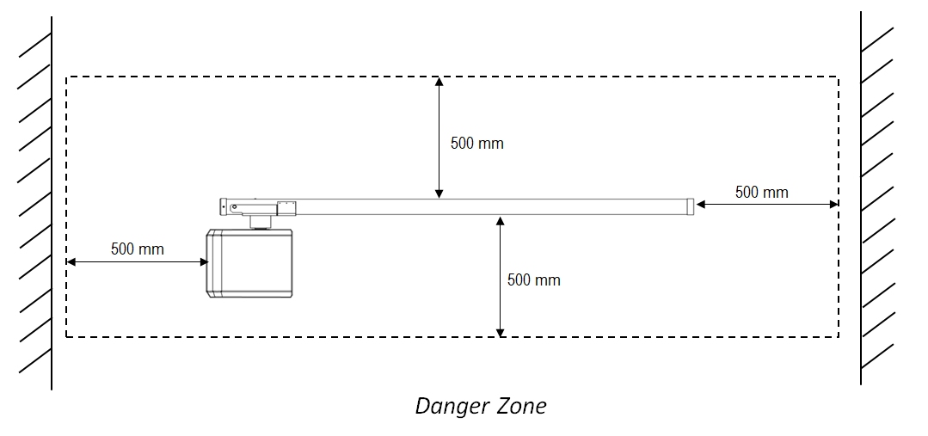

# PRODUCT STRUCTURE AND FUNCTION

## Product Structure

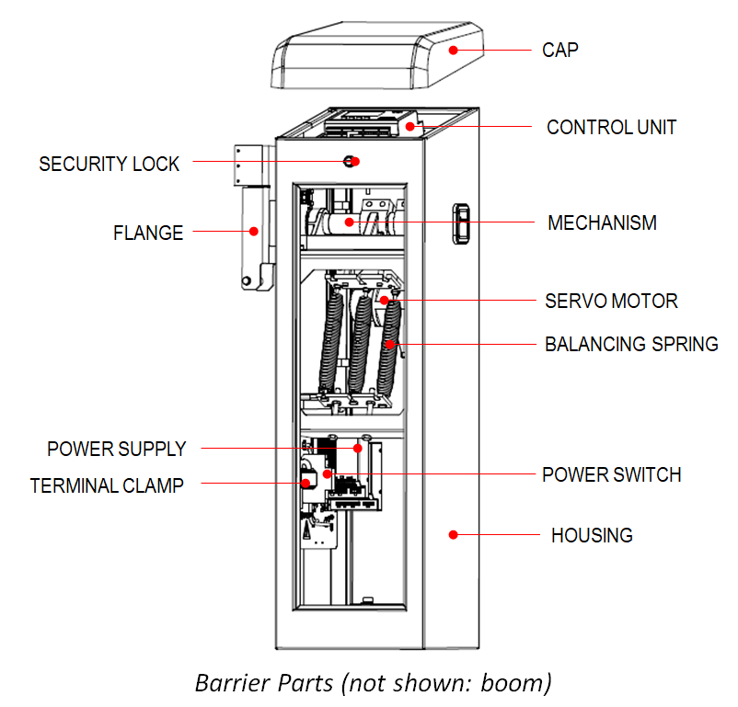

NWD-103B's flange on the right.

## Features

The NWD-103 series barrier is composed of a housing unit with a drive system inside, and a boom arm. A motor, a control unit, and a lever system make up the drive system. The lever system locks the barrier boom in both end positions.

Through RS232 communication, it can monitor the running state of the barrier, change the parameter settings and control the barrier, and report the running state of the barrier to the center.

For safety, sensor devices such as induction loops must be installed on site in all cases. This to ensure that the barrier closes only after a vehicle has passed through.

# TECHNICAL SPECIFICATIONS

## Dimensions

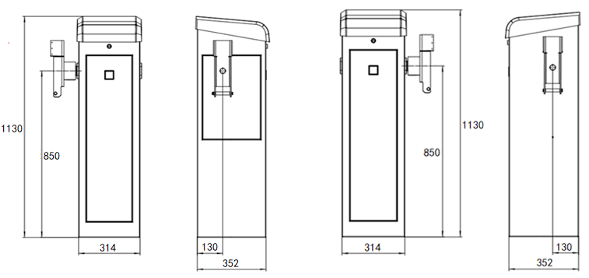

NWD-103/NWD-103A NWD-103B

## Technical Specifications

|  |  |  |  |  |
| --- | --- | --- | --- | --- |
| **Designation** |  | **NWD-103** | **NWD-103A** | **NWD-103B** |
| Opening Time | sec | 0.3 | 0.3 | 0.3 |
| Closing Time | sec | 0.3 / 0.5 / 0.8 | 0.3 / 0.5 / 0.8 | 0.3 / 0.5 / 0.8 |
| Drive Unit |  | HT Servo Motor | | |
| Boom Length | m | 2 | 1.6 | 1.6 |
| Power Consumption (Max) | W | 130 | | |
| Power Supply | VAC | 85 - 264 | | |
| Frequency | Hz | 50 / 60 | | |
| Operating Temperature | °C | -40 to +75 | | |
| Protection Rating |  | IP 55 | | |
| Ambient Humidity | %RH | 95 max | | |
| Barrier Housing Weight (w/o boom) | kg | 55 | | |
| Dimensions (Width x Depth x Height) | mm | 352 x314 x 1130 | | |
| Lifespan | cycle | 10 Million | | |
| Duty Cycle | % | 100 | | |

# TRANSPORT AND STORAGE

## Safety Notes

### Improper Transport

|  |  |
| --- | --- |
| **WARNING** | |
|  | **Danger from improper transport of the barrier boom and housing!**  A person can be severely injured by the weight of the barrier.   * Use lifting equipment. * Carrying and lifting should be done by at least two persons. |

|  |  |
| --- | --- |
| **NOTICE** | |
|  | **Improper transport can damage the barrier system!**   * Transport work should be done by trained personnel only. * Always proceed with utmost caution when unloading packages and during transportation. * Always read safety symbols on the packaging. * Take the greatest care and caution when loading, unloading, and moving the barrier system. * Packaging should be removed only prior to assembly and installation. |

### Heavy Weight of Barrier

|  |  |
| --- | --- |
| **WARNING** | |
|  | **Risk of injury when lifting heavy objects alone!**  A minimum of two persons should lift and carry barrier to minimize possibility of injury. |

## Transport

Housing and barrier boom are delivered separately.

Make use of lifting gears (ex. forklifts, hand tractors, etc.) designed for the weight of the barrier housing and boom.

When transporting, items should be secured by tying cables. It is also important to secure against vibrations.

## Storage

Storage conditions:

Not to be stored outdoors.

Area should be dry and dust free

Protect against direct sunlight.

Avoid mechanical vibrations.

At a temperature: 20 °C

Relative humidity: max. 95 %, non-condensing

Regularly check for condition of packaging and components if the barriers are to be stored for 3 months or longer.

# ASSEMBLY AND INSTALLATION

## Safety Notes

### General

|  |  |
| --- | --- |
| **WARNING** | |
|  | **Danger of improper installation can cause injuries!**  Only duly trained service personnel must do the assembly and installation.   * Ensure that the work area has sufficient space. * The assembly site should be tidy and clean. * Foundations and reinforcement specifications should be complied with. * Ensure that all components are assemblies are the correct ones. * Only use recommended or provided fastening elements. |

### Danger of crushing & shearing barrier boom

|  |  |
| --- | --- |
| **WARNING** | |
|  | **Danger of crushing if minimum safety distance between the boom and other objects is not met!**  Maintain a minimum distance of 500 mm between the boom and other objects. |

### Use of protective attire

Use the following during assembly and installation:

* Work clothes
* Protective gloves
* Safety shoes
* Head protection

## Assembly Guidelines

Before assembly and installation:

* + - * + Set up the foundation for the barrier and conduit installations.
        + Induction loop installation.

During assembly and installation:

* Unpack the barrier and all accessories.
* Mount housing on the concrete foundation.
* Remove all transport protection.
* Mount barrier boom.
* Adjust balancing springs.
* Arrange electrical connections.

## Foundation and Empty Conduits

There are two ways to install the barrier, single-opening and double-opening.

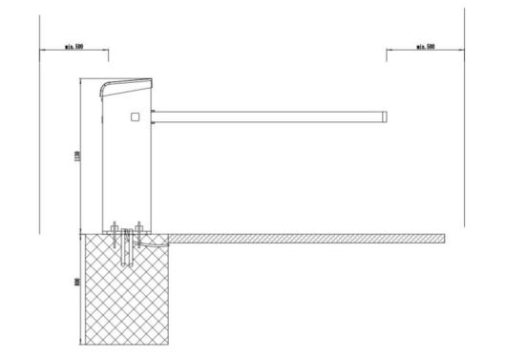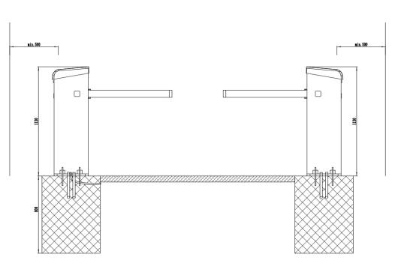

Foundation requirements:

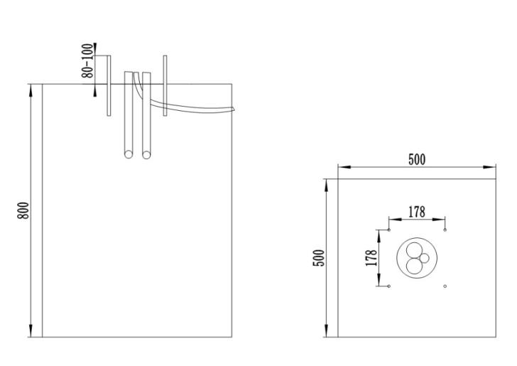

|  |  |
| --- | --- |
| **Foundation floor area** | 500*500mm |
| **Concrete foundation with reinforcement** | BH PC250, Strength=25N/mm² |
| **Embedded anchors** | M8，Protruding height 80-100mm |
| **Conduit pipes** | φ50mm & φ30mm |

### Assembly site

Site must meet the following criteria:

* Barrier should not be put up where there is a danger of flooding.
* There should be a distance of at least 500 mm between the tip of the barrier boom and other objects (ex. walls, masonry, or booth).

### Foundation and reinforcement

The foundation must meet the following requirements:

* + - * + Have sufficient load-carrying capacity.
        + Water cement value: 0.5
        + Foundation depth: at least 500 mm, frost-protected foundation depth to be adjusted to the local situation.
        + Foundation section: 500 mm x 500 mm

### Empty conduits

Must meet the following requirements:

* + - * + Different and empty conduits for mains cable and control line.
        + Empty conduit for induction loop (optional).
        + Should be of sufficient length.

## Unpacking

The barrier is packed inside cardboard boxes with shock absorbing materials to adequately protect it from damage during transport. It is recommended not to destroy the packaging and open the box only just before installation of the barrier.

Prior to opening, check for the condition of the box.

Unpack and lay out all materials and check that everything is complete and are all according to specifications.

Should there be any problem, contact your local distributor.

## Opening barrier housing

The cap and two side covers protect the drive system, tension springs, connection terminals and controller unit. It is normally sufficient to remove only the upper and front side cover.

Use the provided security key to unlock the upper cap and front side cover.

Pull out the front side cover.

Lift up the cap.

After any work, install back the side cover and upper cap, then lock.

## Assemble housing

The housing is mounted to the foundation thru 4 anchors using 2 metal attachment profiles (included in delivery). A mounting kit composed of foundation anchors, washers, and nut may be ordered optionally from Northwest Devices separately.

Should customer prefer to provide their own, the following mounting material specifications should be followed:

4 pcs. foundation anchors

Suitable for concrete

Material: Electro galvanized

Size: M8 x 200

4 pcs Washers DIN 6902 d9.3

4 pcs Washers DIN 9021 d13

4 pcs spring washers DIN128 d8

4 hexagon nuts DIN EN24034 M8

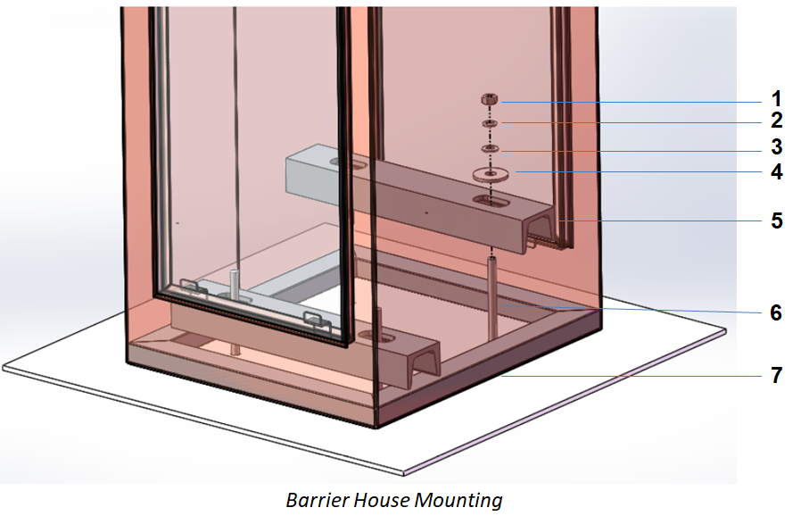

|  |  |  |  |  |
| --- | --- | --- | --- | --- |
| 1 | Nut | 5 | Attachment Profile | |
| 2 | Spring washer | 6 | Foundation anchor | |
| 3 | Washer | 7 | Silicon Sealant | |
| 4 | Washer |  | |  |

Ensure that the foundation concrete is cured and dry.

Make sure that foundation anchors are properly installed at a depth of at 80-100 mm positioned at each four corners of a square, spaced at 178 mm from each other.

Position the housing such that all foundation anchors are well inside.

Place the two metal attachment profiles over the inside base of the barrier, and thru the foundation anchors, then install all washers and nuts without tightening yet.

Align the barrier housing then tighten the screws.

Seal the bottom four sides in contact with the foundation with a gasket or silicon.

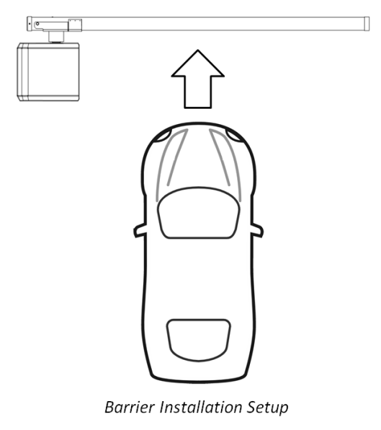 

The opening direction of the boom should be the same as that of the vehicle.

## Change the position of the barrier boom

According to the requirement of field application, the barrier boom can be installed on either side of the housing.

Ensure that power to the barrier is off. Open the housing on both sides.

Loosen the four screws and take out the mechanism using the 10mm inner hexagon.

Install the mechanism from the other side.

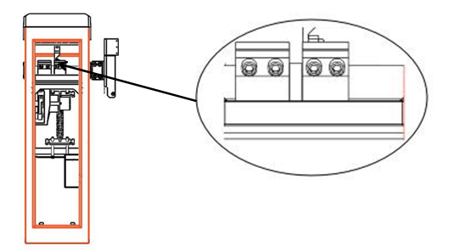

## Install the barrier boom

|  |  |
| --- | --- |
| **WARNING** | |
|  | If no barrier boom is installed, remove the spring and operate to avoid motor damage! |

Insert the steel sleeve into the hole located at the bottom of the barrier boom.

Position the boom in the flange and starting at the bottom portion and with the sleeve inside, insert the screw, holding nut, then tighten.

With enough pressure, hold and push the upper portion of the boom towards the housing then secure the boom well in between the two plastic holders.

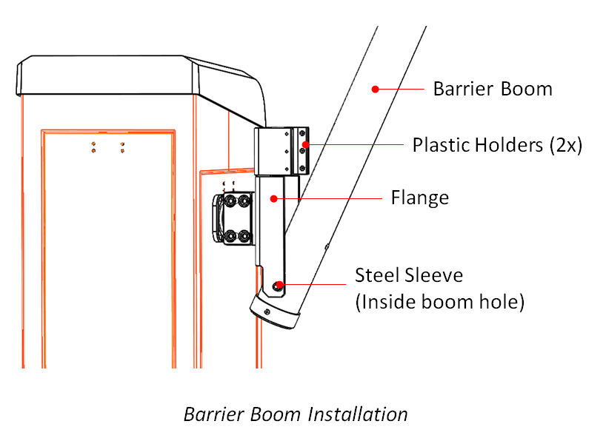

## Check and balancing the springs

|  |  |
| --- | --- |
| **WARNING** | |
| Related image | **Danger of crushing at opened barrier housing at the lever system!**  **Open barrier housing can cause serious injury due to the mechanism inside!**   * Only trained personnel are allowed to check on the lever system. * Turn off power supply when making adjustments on the balancing springs. |

Ensure that power to the barrier is off. Open the housing on both sides.

Position the barrier boom at a 30° angle. If needed, push the lever point inside from the dead point using any tool.

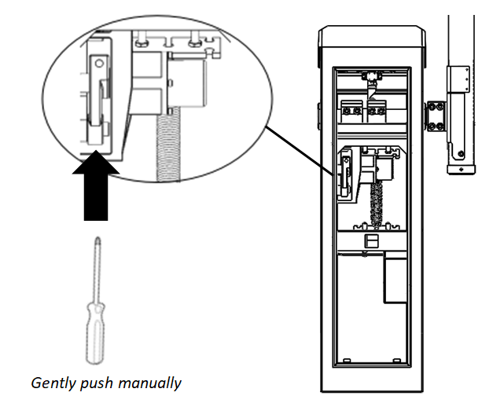

Let go of the barrier boom.

If the boom pulls up slowly, the balance spring is set correctly. Otherwise, the balancing springs need to be adjusted.

Making adjustments to the balancing springs:

Adjust the screws with locknuts using a wrench.

* When the boom lowers, the spring tension is too low.
* When the boom pulls up quickly, the spring tension is too strong.
* When the boom pulls up slowly, the spring tension is correct.

|  |  |
| --- | --- |
|  |  |

Re-install the housing side covers, attach the cap then lock.

## Align barrier housing

|  |  |
| --- | --- |
| **WARNING** | |
|  | **Risk of injury if barrier housing tips over!**  Barrier housing tipping over can cause severe injury!   * During alignment, loosen the attachment screws only slightly. * After alignment tighten the attachment screws. |

Loosen slightly the housing and post attachment screws.

Align the barrier then tighten screws.

Seal housing with silicon.

## Attach safety stickers

The barrier comes together with two safety stickers. Attach one sticker each of the two sides of the housing as shown.

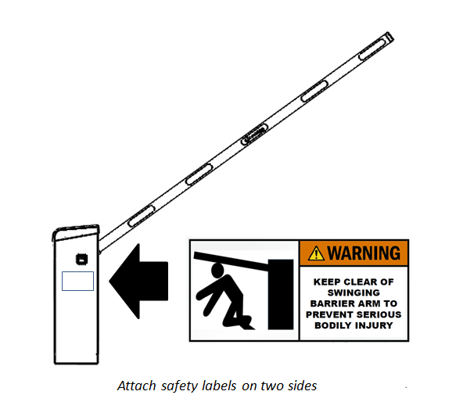

## After assembly and installation

Check the following after assembly and installation:

All transport protection and tapes removed?

Foundation anchors fixed?

All screws tightened?

Balancing springs properly adjusted?

No materials left inside the housing?

Safety stickers applied?

# ELECTRICAL CONNECTION

## Safety Notices

**Electric Voltage**

|  |  |
| --- | --- |
| **DANGER** | |
| Image result for warning safety symbols | **Danger of electric voltage!**  It can be lethal to be in contact with live wires.   * Immediately switch off power if there are obvious signs of damage to insulation. Arrange to have these repaired. * Only trained electricians are to work on the electrical system. * Ensure that power is off and prior to performing any work. Test that there is no voltage! * Never bypass or deactivate fuses. * Correct amperage specifications should fuses need to be replaced. * Always keep moisture and dust away from live parts as these may cause a short circuit. |
| **WARNING** | |
|  | **Danger by improper installation!**   * Only qualified electricians are to perform any electrical installation. * Ensure the assembly area is clean and tidy to avoid any cause of accident due to components that are lying around. * All screw connections should be tightened. |

**Hot Surface**

|  |  |
| --- | --- |
| **WARNING** | |
| Image result for hot surface safety symbol | **Danger from hot surfaces!**  Motor surface may be hot and can cause burns.   * Hot surfaces are not to be touched. * Wait for a few minutes for hot surfaces to cool down after switching off power. * Use gloves to protect against burns. |

**Electromagnetic Interference**

|  |  |
| --- | --- |
| **NOTICE** | |
|  | **Interference from cables due to presence of electromagnetism can cause barrier malfunctions!**   * Cables for control and power are to be in separate conduits. * Cables used should conform to the electrical circuit plan. * Only install parts and cables approved by the manufacturer. * Additional electrical and electronic parts must be EMC certified and must not exceed their indicated EMC value limits. |

**Working Attire and Equipment**

Use the following when installing:

* Work clothes
* Protective gloves
* Safety shoes
* Protective helmet.

## Protective Electrical Devices

The user should provide protective electric devices such as a Residual-Current Device (RCD) or Ground Fault Circuit Interrupter (GFCI) to the main supply going into the barrier.

## Power supply connection

Near the lower portion of the housing, locate the terminal clamp.

Connect the mains power supply lines to the terminal clamp, in accordance to local electrical codes.

Line specifications should be from AWG15 to AWG13.

Secure the power cable to the metal tabs with cable ties.

It is suggested that the DCU of NWD-103A be powered separately.

## Safety Connection

Single-opening: Connect the safety signal to the safety device input clamp of the SLC control unit. The safety signal should be the relay normally closed signal. The input of the safety device is detailed in the SLC instructions.

Double opening: Connect the safety signal to DCU. The safety signal should be the relay normally open signal. Detailed connection can be seen in DCU instructions.

If you buy the VDU module,Single open, VDU's normally closed signal is connected to the input of SLC's Safety devices input; double open, VDU's normally open signal is connected to the P4 clamp of DCU. we will install and complete the wiring. You only need to connect the loop and relay output signal.

## DCU Connection

DCU(Double Control Unit),Only for NWD-103A barrier, used for double-open barrier control, status output, safety signal connection together.

|  |  |
| --- | --- |
| P1 | Control and state of barrier 1 |
| P2 | Control and state of barrier 2 |
| P3 | DCU output signal |
| P4 | DCU Safety Input |
| P5 | DCU Power Supply |
| S1 | Barrier 1 State Signal Switch |
| S2 | Barrier 2 State Signal Switch |
| S3 | Barrier 1 Control Signal Switch |
| S4 | Barrier 1 Control Signal Switch |
| LED | Lighting means work. |

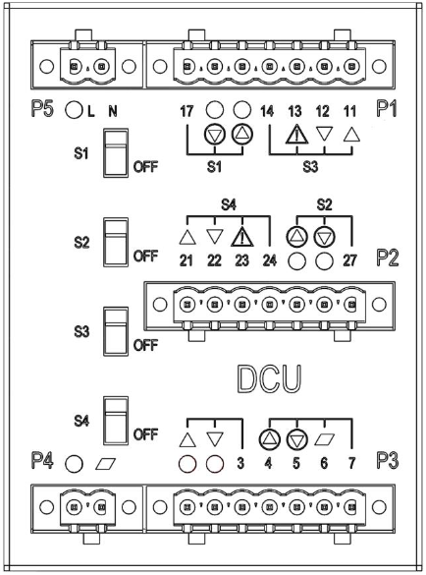

|  |  |  |  |
| --- | --- | --- | --- |
| **P1/P2 Clamp group meaning** | | | |
| **DCU Clamp** | **Description** | **Function** | **Connect SLC clamp** |
| 11/21 | Dry contact | Open Control | IN1 |
| 12/22 | Dry contact | Close Control | IN4 |
| 13/23 | Dry contact | Safety Control | Safe”IN” |
| 14/24 | / | Control COM | 24V |
| 15/25 | Dry contact | Open Status | NO1 |
| 16/26 | Dry contact | Close Status | NO2 |
| 17/27 | / | Statue COM | C1-3 |

|  |  |  |  |  |
| --- | --- | --- | --- | --- |
| **P3-P5 Clamp group meaning** | | | | |
| **DCU Clamp** | | | **Description** | **Function** |
| P3 | 1 | 3 | Dry contact | Open Control |
| 2 | Dry contact | Close Control |
| 4 | 7 | Dry contact | Open Status |
| 5 | Dry contact | Close Status |
| 6 | Dry contact | Vehicle Exists |
| P4 | / | | Dry contact | DCU Safety Input |
| P5 | L | N | Power Supply | DCU Power Supply 220VAC |

|  |  |
| --- | --- |
| **Switch S1-S4 meaning** | |
| **S1** | If you want P1 to have no state output, adjust S1 to OFF |
| **S2** | If you want P2 to have no state output, adjust S2 to OFF |
| **S3** | If you want P1 to have no control signal, adjust S3 to OFF |
| **S4** | If you want P2 to have no control signal, adjust S4 to OFF |

The specifications of all clamps shall be AWG20 to AWG14.

Electrical Value of Relay：Max.2A, 250VAC, 60 W/62.5VA.

# START UP AND OPERATION

## Safety Notice

|  |  |
| --- | --- |
| **WARNING** | |
|  | **Danger by improper start-up and operation!**  Improper start-up and operation can cause severe or lethal injury.   * Operation should only be done by trained personnel. * Observe the area around the barrier’s Danger Zone. * Housing covers should be mounted correctly. |

## Commissioning

Before starting, do the following:

* + - * + Insure that all transport protections were removed.
        + Check electrical connections.
        + Check the position of the barrier boom.
        + Check balancing springs and make adjustments if needed.

## Switching on and switching off the barrier

|  |  |
| --- | --- |
| **NOTICE** | |
|  | **A too quick power up after a shutdown can damage the barrier!**  Wait for 10 seconds after shutdown before switching on again the power. |

### Switching on

1. Remove the barrier housing cap and front side.
2. Switch on the barrier via the 2-pole mains switch.
3. Depending on Start-Up set up, the barrier boom slowly moves from horizontal to vertical position and vice versa (Mode 1), or stays at vertical position (Mode 2) for safety.
4. Mount the front side cover, put on cap and lock.

### Switching off

1. Remove the barrier housing cap and front side
2. Switch off the barrier via the 2-pole mains switch.
3. Depending on Power Failure set up and balancing spring tension, the barrier boom goes vertical (Open) or horizontal (Stop).
4. Mount the front side cover, put on cap and lock.

## Putting the barrier temporarily out of operation

During high winds

|  |  |
| --- | --- |
| **WARNING** | |
|  | **Risk of injury from barrier boom in case of high wind speeds!**  During extreme high winds, the barrier boom may be moved from its end position. The moving boom can severely injure a person.  Keep open the main power supply  Remove the barrier boom if necessary |

|  |  |
| --- | --- |
| **NOTICE** | |
|  | **Possible damage to the equipment by condensed water when mains voltage is switched off can cause damage to the barrier!**  Maintain barrier mains voltage. |

Should the barrier need to be put out of operation for a longer period, do the following:

Switch barrier off.

Detach barrier boom if needed.

Protect housing and barrier boom from the environment.

Switch barrier back on.

# SLC CONTROL UNIT

## Control Unit Layout

|  |  |
| --- | --- |
| 1 | Power supply connection |
| 2 | Ethernet |
| 3 | Motor communication |
| 4 | Safety devices input |
| 5 | Sensor input / Boom dislocation input |
| 6 | Test switch |
| 7 | LCD panel |
| 8 | Selection keys |
| 9 | Control signal input |
| 10 | State signal output |
| 11 | Serial port |
| 12 | Digital signal output |

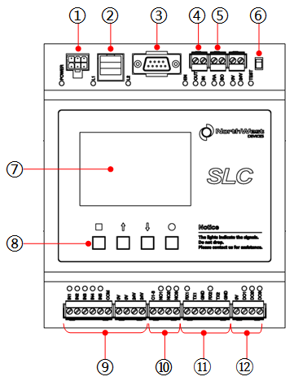

|  |  |
| --- | --- |
| 1 | Barrier type |
| 2 | Current programme mode |
| 3 | Current state of the barrier |
| 4 | Current function of the left button |
| 5 | Current function of the right button |

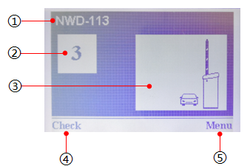

**The Meaning of Selection keys Symbols**

View errors ; Return in the menu.

Manually open the barrier ; Move cursor upwards ; Increase figure.

Manually close the barrier ; Move cursor downwards ; Decrease figure.

Enter the menu ; Select desired option ; Save selected values.

## Input and Output

|  |  |  |
| --- | --- | --- |
| **Clamp** | **Description** | **Function** |
| IN1 | Input 1 | Open low priority |
| IN2 | Input 2 | Open and count |
| IN3 | Input 3 | Open high priority |
| IN4 | Input 4 | Close |
| IN5 | Input 5 | Close |
| NO1 | Output Relay 1 | Open |
| NO2 | Output Relay 2 | Closed |
| NO3 | Output Relay 3 | Error |
| DO1 | Digital 1 | Signal light A |
| DO2 | Digital 2 | Signal light B |
| DO3 | Digital 3 | Signal light C |
| RA | Radar signal input | Vehicle existence |
| BO | Boom signal input | Boom dislocation |

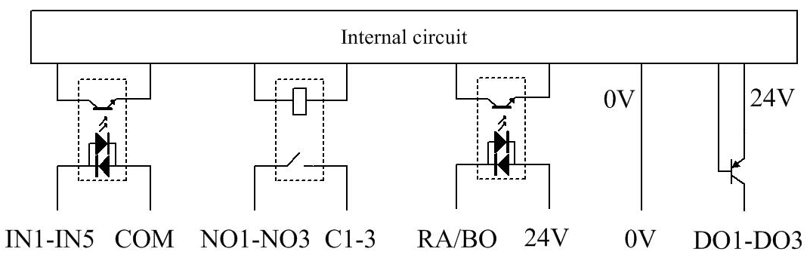

**IN1-IN5:** Input voltage 24VDC±10％ , Input current ＜10mA per input.

**NO1-NO3:** Max. voltage 30V DC/AC , Max. current 1A .

**RA/BO：**Input voltage 24VDC±10％ , Input current ＜10mA per input.

**DO1-DO3:** Output voltage 24VDC±10％ , Input current 100mA .

**The specifications of all clamps shall be AWG20 to AWG14.**

## Menu

### User Mode

|  |  |
| --- | --- |
| **Mode 1** | Barrier boom is always open (vertical position) and only closes when a continuous signal is received. |
| **Mode 2** | Depending on the duration of the continuous signal, the barrier boom can be moved to any angle. |
| **Mode 3** | The barrier is opened and closed when a signal pulse is received by two separate inputs. The pulse should be between 100 and 300 ms. |
| **Mode 4** | Automatic closing of the barrier boom happens when the signal is originating from a safety device. |

### Barrier Setup

|  |  |
| --- | --- |
| **Speed** | Configure closing speed as Fast , Medium , or Low.  The three speeds of NWD-103A and NWD-103B are adjustable.NWD-103 can only be adjusted to medium speed as soon as possible. |
| **Delay** | **Close Delay:**  Length of time barrier boom closes after receiving signal (0…15s, default 0s).  **Impact Delay:**  Length of time barrier boom closes after collision is detected (0…30s, default 0s). |
| **Angle** | When the barrier boom is closed, it will not anymore open if the angle is less than what has been configured. Angle can be set from 0° to 40°, default 10°. |
| **Impact** | **Response:**  The state of barrier after impact.  **Restart:**  Ways of recovery after impact.  **Sensitivity:**  Choose impact sensitivity as either: High, Medium, or Low. |
| **Start-Up** | Describes how barrier boom opens and closes upon return of power. |
| **Power Failure** | **Stop:**  On power outage, the barrier boom remains motionless.  **Open:**  On power outage, the barrier boom is moved to the open (vertical) position by the balancing springs of the lever system. The tension springs must be set correctly and the boom must not be held down by any external force. |
| **Vehicle count** | When the user mode is set to automatic mode (mode 4), the counting function can be turned on in the menu, and the LCD displays a counting value. |
| **Auxiliary interface** | **Radar:** Triggered to mean detection of vehicles or pedestrians  **Boom:** Triggered to mean the boom dislocation . |
| **Serial port** | This is a full duplex RS232, RX1, TX1, GND at the output clamp of the control unit. The LED flashing on the left side means that data is being received, and the LED flashing on the right side means that data is being sent. |
|  |  |

# TROUBLESHOOTING

This section describes possible causes of malfunctions and troubleshooting tasks. In case problems cannot be repaired by means of the recommendation actions, please contact your dealer. Only purchase spare parts from your dealer or from the manufacturer.

## Safety Statements

|  |  |
| --- | --- |
| **WARNING** | |
|  | **Danger of major injury from improper troubleshooting!**  Improper troubleshooting can cause injury, even death.   * Electrical work should only be performed by qualified electrical personnel. * Anticipate possible movement of barrier boom. * Ensure that assembly space is sufficient. * Keep assembly site clean and tidy. * Turn power off if any component is found to be damaged. * Make sure that all covers are mounted after troubleshooting. |

## Troubleshooting Table

|  |  |  |
| --- | --- | --- |
| **Problem** | **Possible Cause** | **Corrective Action** |
| **Barrier boom does not close** | Loop not connected | Connect loop |
| Vehicle detector not properly configured | Review and correct configuration of vehicle detector |
| Defective loop | Replace loop |
| Connection problem at input terminals | Check connection at terminal inputs |
| Loop detector reporting presence even when there is no vehicle | Check and adjust loop frequency and sensitivity if needed. |
| **Barrier does not close immediately after through traffic, but only after the hold-open time.** | Too long delay time. | Adjust closing delay parameter accordingly. |
| Safety device not responding properly | Check sensitivity of the  safety device and adjust if needed |
| **Barrier does not close all the way down** | Tension on balancing spring set too high | Adjust balancing spring tension |
| **Barrier closes even when there is a vehicle present on the safety sensor.** | Too high trigger sensitivity set for the vehicle detector. | Check sensitivity of the  loop and adjust if needed. |
| Faulty loop. | Check loop. |

## Control Unit Error Codes

|  |  |  |
| --- | --- | --- |
| **Error Code** | **Meaning** | **Action Needed** |
| E1030 | Motor over temperature | If the ambient temperature is normal, contact vendor |
| E1031 | Motor over voltage | Check power module |
| E1032 | Motor under voltage | Check power module |
| E1033 | Motor error | Inspect motor and wiring |
| E1034 | Motor over current | Check power module |
| E1035 | Motor need ACK | Contact vendor |
| E1040 | Motor communication error | Inspection of motor and wiring |
| W1060 | Barrier open impact | Check for collisions |
| W1061 | Barrier close impact | Check for collisions |
| W1062 | Power down | Check if power supply is interrupted |

## Resetting the Barrier

The resetting of the Control unit is done simply by switching off the power supply and switching it on again after 10 seconds.

|  |  |
| --- | --- |
| **NOTICE** | |
|  | **A too quick power up after a shutdown can damage the barrier!**  Wait for 10 seconds after shutdown before switching on again the power. |

# REPAIR

## Safety

General

|  |  |
| --- | --- |
| **WARNING** | |
|  | **Danger from improper repair!**  Inappropriate repair can cause severe or lethal injuries.   * Only authorized NWD-103 service personnel can perform any repair work. * Ensure sufficient assembly space prior to starting any work. * Keep the assembly area clean and tidy. * Use only original or Northwest Devices approved spare parts. * All covers should be correctly mounted back after repair completion. |

Switching off power supply

|  |  |
| --- | --- |
| **WARNING** | |
|  | **Danger when switching off the barrier!**  Only when the barrier boom is mounted should power supply be turned off.  Only switch off power when either the barrier boom is installed or tension springs are relaxed as indicated when the flange is vertical. |

## Spare Parts

|  |  |
| --- | --- |
| **WARNING** | |
|  | **Danger of injury by wrong spare parts used!**  Wrong spare parts used can damage, result to malfunction, and create safety issues.  Only approved manufacturer’s original spare parts are to be used. |

Acquire spare parts only from the manufacturer or their authorized dealer.

**Northwest Devices Corporation**

Phone/Fax：+1（905）267 3413 / +1（905）267 3401

Address: 77 City Centre Drive, Suite 501, East Tower, Mississauga, ON, L5B 1M5, Canada

E-Mail: info@northwest-devices.com